**USE GUIDE**

1. **Client**

**1.1.Register**

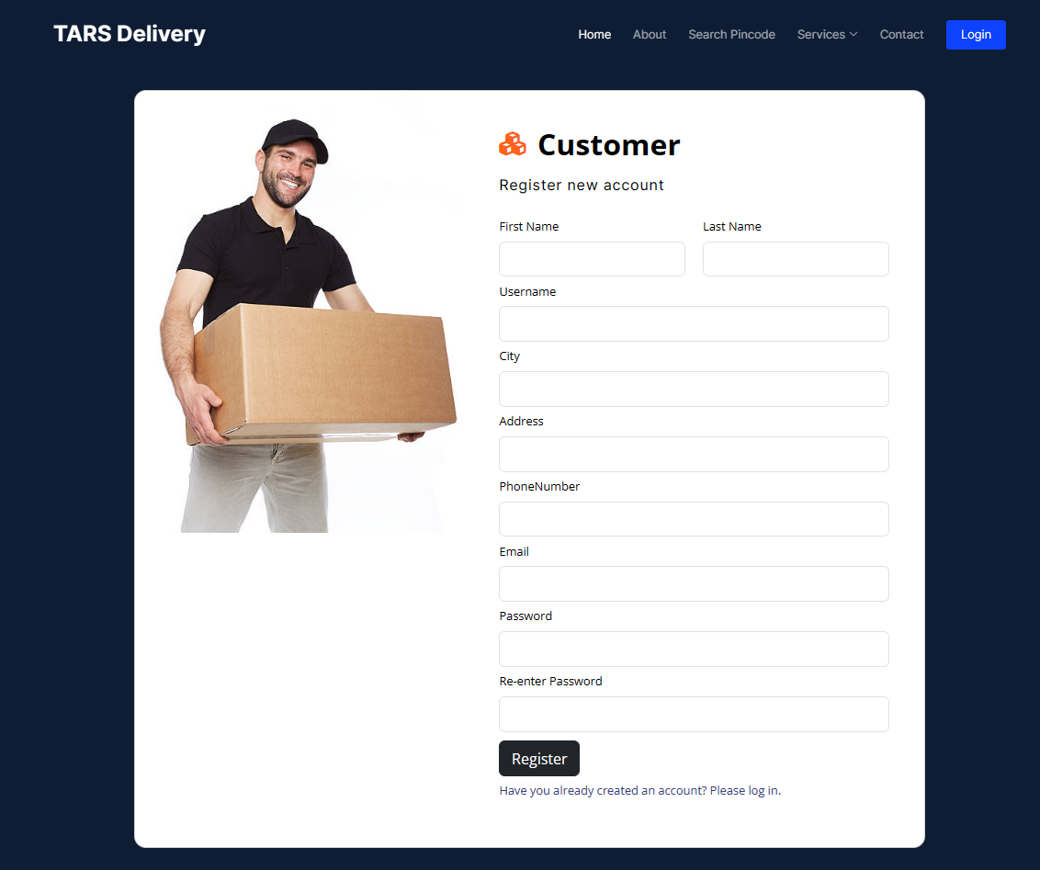Customer must register and then login to make order

1.2. Login

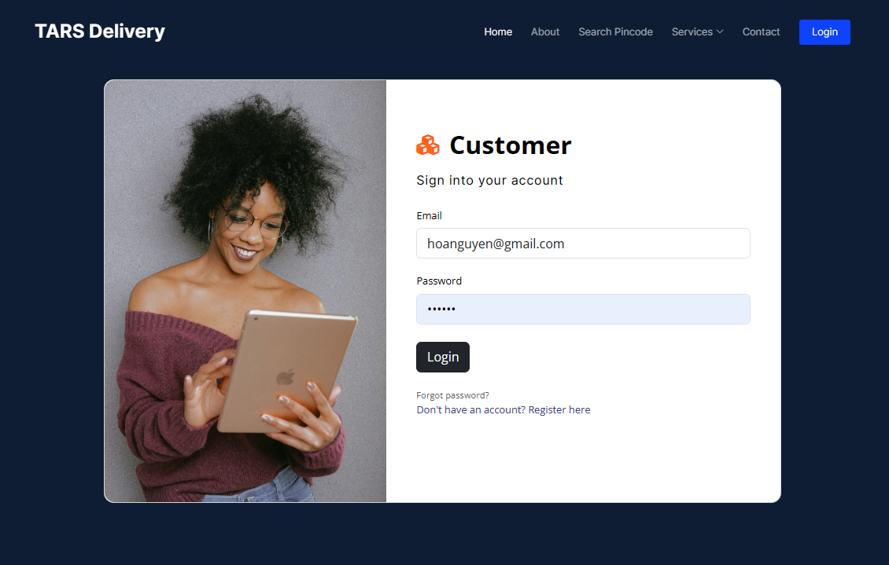

* 1. **Tracking order**

After make order successfully, customer will received an order number to track delivery history of parcel or money transfer



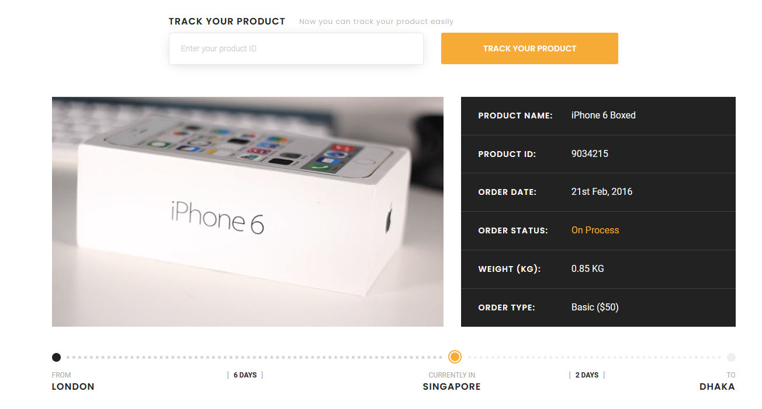

* 1. **Calculate shipping fee**

When input dimensions and weight of parcel, location of receiver and sender, type of parcel and then choose service type, estimated fee will be calculated.

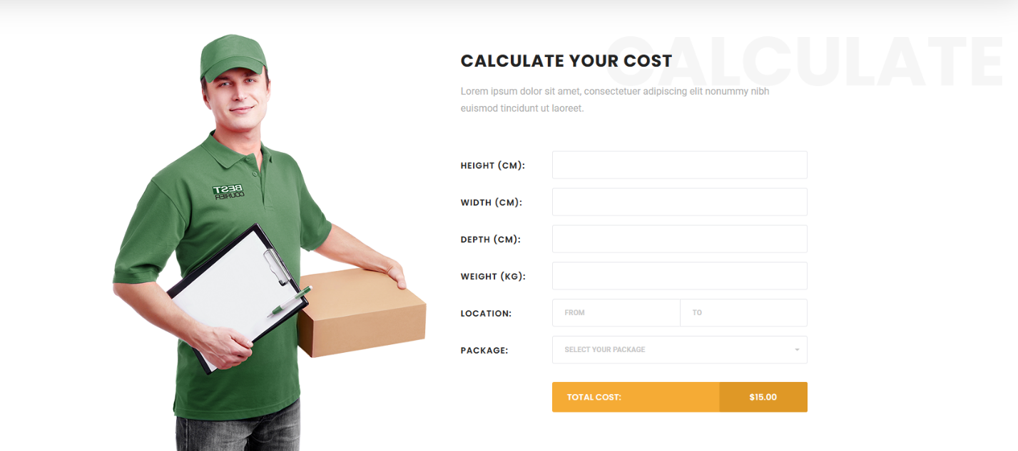

* 1. **Parcel Order Create:**

When you log in successfully, the platform of website will be presented. And this page will help you to create parcel order.

* 1. **Money Order Create:**

Next Page, you can do the money order page if you click on Money Order Section:

* 1. **Money Order Page:**

You can see all money orders page that you have made:

* 1. **Parcel Order Page:**

You can see all parcel orders that you have made:

**2.Admin:**

**2.1. Parcel Order Manage**

In this page, you will see the all the client’s order that they have made. The admin or employee will update the status of order.

**2.2. Parcel Order Update Form**

The admin or employee will update the elements of order they have, when they click on Edit link

**2.3. Service Management Page:**

The admin or employee will update the elements of services they have, when they click on Edit link

**2.4. The Service Price Management Page:**

The admin will update the price of the order services that the company proposes.

**2.5 Money Order Management Page**

The admin will update the status of the order.

